

17

Target: ___/23 or ____ % 👍 👎

Year 8 HASS- Civics and Citizenship

***Task 2b: In Class Documentary Analysis Validation (2.5%)***

***Name: ____________________ Teacher: ________________***

**Time: 5 minutes reading time and 50 minutes working time.**

Part A: Validation Questions

1. State what year the drumline program was introduced in Western Australia. (1 mark)

1. State two species of sharks (as specified in the documentary) that are protected under Australian Law. (2 marks)

1. Describe how the drumline program worked (3 marks)

1. Outline why Kyle Burdens story is significant in the documentary. (3 marks)

1. Describe why the Sea Shepherd group wanted the drum line program to be abolished, and why they believe it is important to protect sharks. (4 marks)

1. Explain what direct action is and provide two examples of direct action present in the documentary. (4 marks)

**END OF PART A**



29

Target: ___/15 or ____ % 👍 👎

Year 8 HASS- Civics and Citizenship

***Task 3: In Class Short Answer Response (7.5%)***

Part A: Multiple Choice Questions

Circle the correct answer to the following questions. (1 mark each)

**1 Democratic freedoms allow Australians to participate actively in democracy; however:**

**A** the bill of rights protects minority groups.

**B** there is no formal document that protects these freedoms.

**C** these freedoms interfere with responsible government.

**D** the members of parliament must be accountable to their electorates.

**2 Which of the following is NOT an accurate description of freedom of speech:**

**A** having the freedom to form and hold opinions.

**B** having the freedom to receive and impart information.

**C** having the freedom to say whatever you want without restriction.

**D** having the freedom to communicate ideas without using words.

**3 Freedom of speech is an important component of democracy because:**

**A** it allows people to share their ideas without government restraint.

**B** it allows people to express their opinions freely.

**C** it allows people to debate and criticise the government.

**D** it allows people to communicate their artistic expressions.

**4** **In the Criminal Code 1995, people can be punished because of whom they are connected to, rather than because of what they actually do. This is a concern because it limits the individual’s right:**

**A** to freedom of speech.

**B** to freedom of assembly.

**C** to freedom of movement.

**D** to freedom of association.

**5 Which of the following is NOT an example of Direct Action:**

**A** Petitions.

**B** Marches.

**C** Rioting.

**D** Negotiations.

**6 Types of Laws in Australia include:**

**A** Rules, Statutes, Criminal and Civil.

**B** Common, Criminal, Civil and Statute.

**C** Common, Civil, Uncivil and Criminal.

**D** Common, Rules, Civil and Uncommon.

**7 Which of the following best defines Rules:**

**A** A set of explicit regulations or principles governing an activity.

**B** A set of regulations that a community recognises as regulating the actions of members.

**C** An individual having absolute power, without limitations, over others.

**D** A system of organisation where the members are given power.

**8 Which of the following best defines Laws:**

**A** A set of explicit regulations or principles governing an activity.

**B** A set of regulations that a community recognises as regulating the actions of members.

**C** An individual having absolute power, without limitations, over others.

**D** A system of organisation where the members are given power.

**9 A Statute Law is produced in:**

**A** Parliament.

**B** Kirribilli House

**C** Buckingham Palace.

**D** Courts.

**10 Common Law is produced in:**

**A** Parliament.

**B** Kirribilli House

**C** Buckingham Palace.

**D** Courts.

Part B: Short-answer questions

1. **List** the five democratic freedoms that are valued and upheld within Australia.

*(5 marks)*

* *________________________________*
* ________________________________
* ________________________________
* ________________________________
* ________________________________

**2** Define one of the five democratic freedoms, with the use of an example to support your response. *(2 marks)*

__________________________________________________________________________

__________________________________________________________________________

__________________________________________________________________________

__________________________________________________________________________

**3** According to the graph (Source 1.2.1), government intervention in which form of free expression has the **most** support from the public? *(1 mark)*

___________________________________________________________________________

**4** According to the graph (Source 1.2.1), government intervention in which form of free expression has the **least** support from the public? *(1 mark)*

___________________________________________________________________________

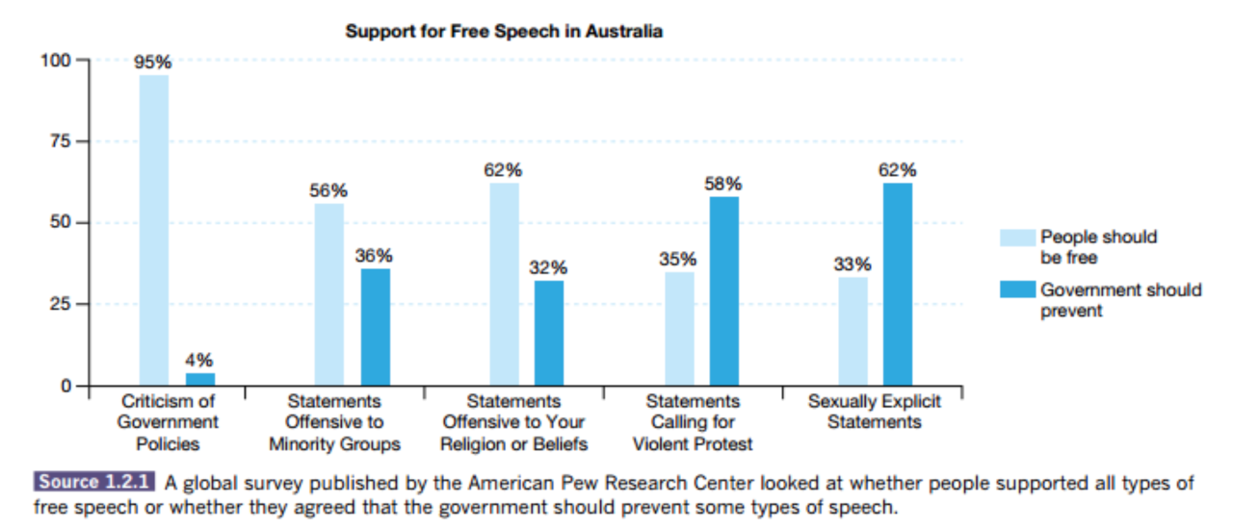_____________________________________________________________

**5** Compare and contrast the difference between Civil and Criminal Laws, using an example of each to support your response  *(5 marks)*__________________________________________________________________________________________________________________________________________________________________________________________________________________________________________________________________________________________________________________________________________________________________________________________________________________________________________________________________________________________________________________________________________________________________________________________________________________________________________________________________________________________________________________________________________________________________________________________________________________________________________________________________________________________

**6** Using your knowledge of the different types of laws, label the scenarios contained in the table below as either *civil* or *criminal. (5 marks)*

|  |  |
| --- | --- |
| **Scenario** | **Type of Law**  *Civil or Criminal* |
| A 22 year old man is using his mobile phone to text a friend and is driving too fast (but not above the speed limit) as he approaches a roundabout. A bike rider goes through the roundabout very quickly in front of him and he clips the back wheel of her bike with his car. The bike rider is killed. |  |
| A security guard (the plaintiff) was injured at work when she was punched by a patron outside a party. She injured her neck and back and needs surgery. She does not recover from her injuries and becomes depressed. |  |
| Elaine, a 35-year old teacher, got a ticket for driving 75 miles per hour in a 35 mile per hour zone. |  |
| Jane, 25 years old, was caught stealing $150 worth of candies from a nearby department store. She had been apprehended by the police twice before. |  |
| Jan was invited to dinner at Richard’s apartment. Richard had just completed mopping the apartment and the floor was still very wet. Jan took two steps into the apartment, fell on her side and broke a finger |  |

**END OF PART B**

**END OF ASSESSMENT**